

IT unit 18.2

By Adam Chu



Contents

No table of contents entries found.

# Introduction

The LRC at Weymouth College are using a paper system for their equipment rental for Lectures, they have asked me to create a relational database to replace this system. In this design document I will elaborate on the basic design for the new system.

I will show the Relationships and the Data Flow with diagrams these will follow criteria given to us by the LRC themselves. I also have to talk about form & report design using the Weymouth College Theme & House Style.

# Level 0 & Level 1 Data Flow Diagrams (DFDs)

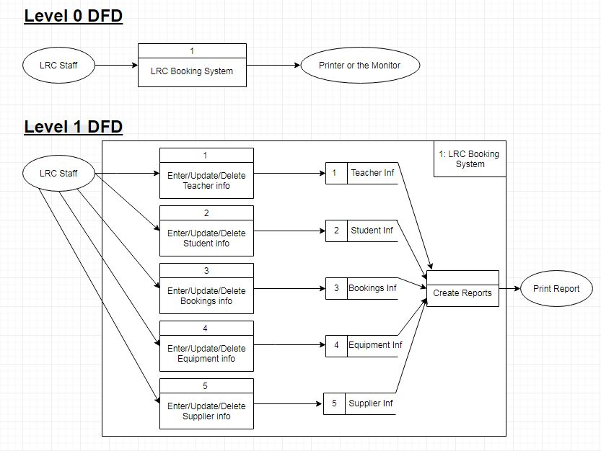

# Entity Relationship Diagram

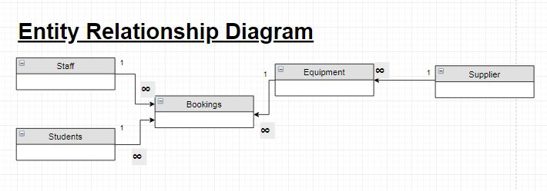

# Data Dictionaries

## Lecturer Info

|  |  |  |
| --- | --- | --- |
| **Field Heading** | **Data Type** | **Notes** |
| Lecturer ID | AutoNumber | Short Integer, Primary Key |
| Title | Short Text | Field Size: 6, Required: Yes, Drop Down List |
| First Name | Short Text | Field Size: 20, Required Yes |
| Surname | Short Text | Field Size: 20, Required Yes |
| Initials | Short Text | Field Size: 2, Required Yes |
| Extension Code | Short Text | Field Size: 5, Required Yes |
| Address1 | Short Text | Field Size: 20, Required Yes |
| Address2 | Short Text | Field Size: 20, Required No |

## Student Info

|  |  |  |
| --- | --- | --- |
| **Field Heading** | **Data Type** | **Notes** |
| Student ID | AutoNumber | Short Integer, Primary Key |
| Title | Short Text | Field Size: 6, Required: Yes, Drop Down List |
| First Name | Short Text | Field Size: 20, Required Yes |
| Surname | Short Text | Field Size: 20, Required Yes |
| Initials | Short Text | Field Size: 2, Required Yes |
| Address1 | Short Text | Field Size: 20, Required Yes |
| Address2 | Short Text | Field Size: 20, Required No |

## Bookings Info

|  |  |  |
| --- | --- | --- |
| **Field Heading** | **Data Type** | **Notes** |
| Staff ID | Number | Short Integer, Foreign Key from Staff Info (Have it so Staff or Student ID is shown) |
| Student ID | Number | Short Integer, Foreign Key from Student Info (Have it so Staff or Student ID is shown) |
| Equipment ID | Short Text | Field Size: 20, Required Yes, Foreign Key from Equipment Info, Drop Down List |
| Collection Date | Date | DD/MM/YYYY, Required Yes |
| Return Date | Date | DD/MM/YYYY, Required Yes |

## Equipment Info

|  |  |  |
| --- | --- | --- |
| **Field Heading** | **Data Type** | **Notes** |
| Barcode | Short Text | Field Size: 7, Required Yes |
| Equipment Type | Short Text | Field Size: 20, Drop Down List, Required Yes |
| Equipment Name/ID | Short Text | Primary Key, Field Size: 40, Required Yes |
| Supplier ID | Number | Foreign Key, Auto Number |

## Supplier Info

|  |  |  |
| --- | --- | --- |
| Supplier ID | Auto Number | Primary Key |
| Supplier | Short Text | Field Size: 20, Required Yes |
| Supplier Telephone No. | Number | Field Size: 15, Required Yes |
| Supplier Order Reference | Short Text | Field Size: 20, Required Yes |